Oastlers Policy

Approved by Governing Body On | September 25
To be Reviewed On | September 26
Signed on Behalf of the Governing Body | David Ward

Careers Policy

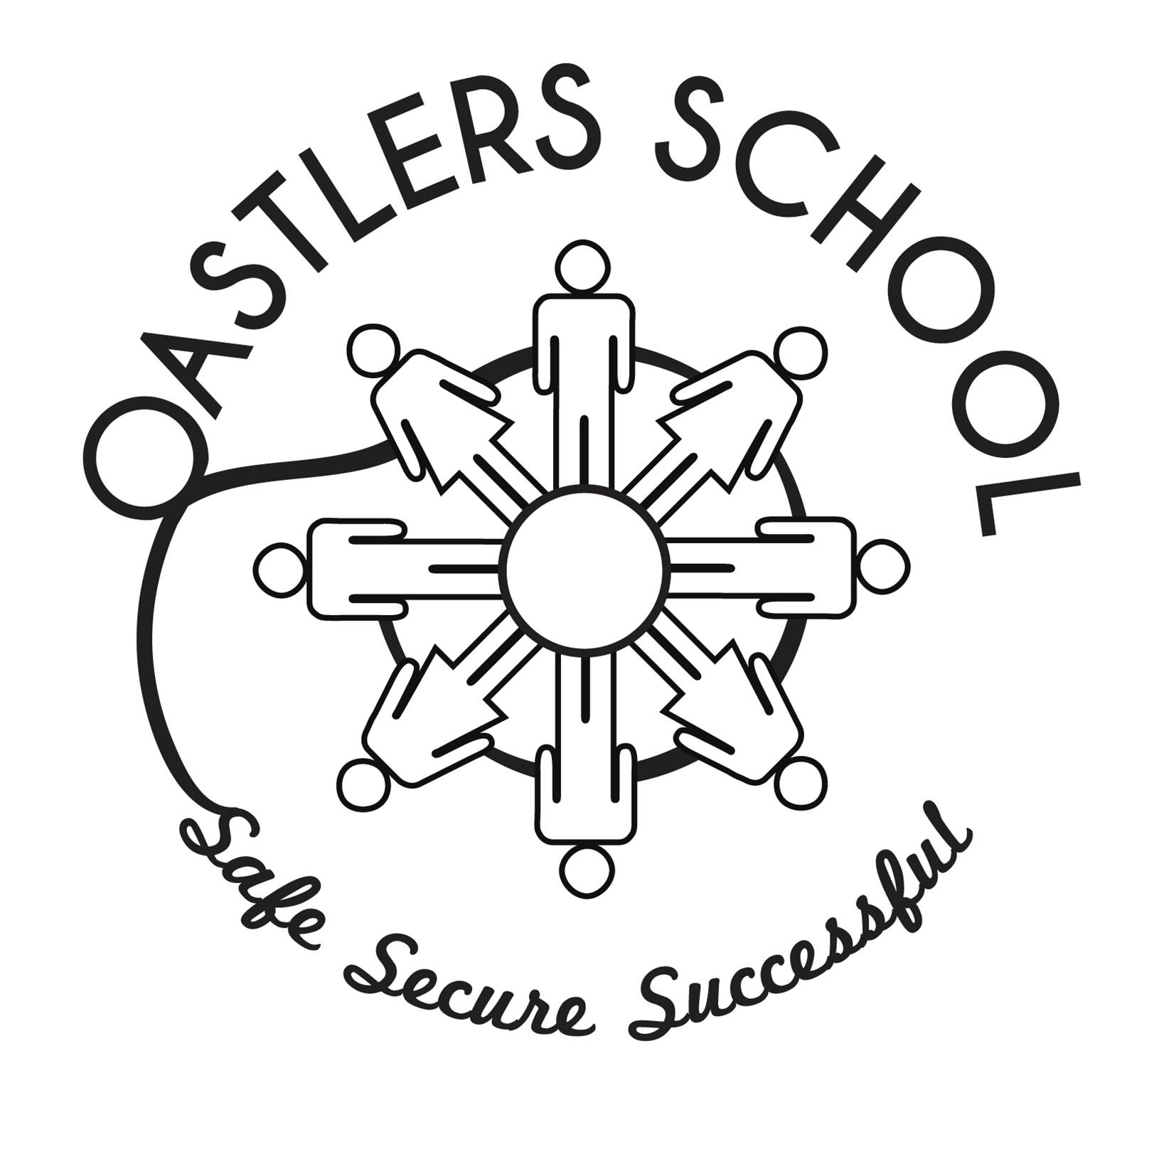

Careers Policy Statement
Our careers offer is varied and wide ranging. In 2025/26 we are further developing our workplace employment strategy aligning it with the Bradford Learning Sector Pathway Framework. This framework is underpinned by Bradford MDC’s Skills House, the strategic pathway to provide young people with a clear and coherent structure for careers education, keeps pace with the rapid technological changes in the district. This will enable Oastlers to work closely with local businesses and organisations to ensure our approach is shaped by real-world industry needs.
Our model has at its core the Gatsby Benchmarks, placing individual learners at the heart of their own transition process, either into further education or employment; we ensure each receives a wide range of opportunities as they progress through school. Learners are supported to develop their decision-making and self-advocacy skills by engagement within the curriculum, professional careers advice, vocational opportunities, links to employers and their places of work.
Our curriculum offer includes discrete learning activities that build on a range of partner organisations that are at the heart of our community. Careers is not marginalised within our school, it is integral, embedding whole school events and building on the aspirations of our learners during their journey through our school. Oastlers employability training is equally innovative, as we work with industry role models to embed interview and CV training, developing problem solving, persistence and the can-do attitudes that employers tell us they want. Our learners will need to be match fit for employment, they need to know what the world of work expects and they will have to believe they have the skills to be successful when they leave our school. Our offer ensures they have every chance of success.
Introduction
Our partnerships with employers have created opportunities that support our learners develop their understanding of the options available after they leave Oastlers, helping them make informed choices that align with their aspirations. Our relationships with work-based learning providers are key to ensuring transitions from education to the world of work.
These will now be enhanced as we work with Skills House on two distinct learning sector pathways:
- Health and Social Care
- Transport, Distribution & Logistics

The implementation plan will start with Skills House staff introducing local labour market information across both of these sectors. They will do this in assemblies and school visits. This is to be followed by a three-stage process:
Step 1 – Introduction to the sector
Step 2 – Developing skills within the sector
Step 3 – Your next steps into the sector
This plan is experiential in nature, aiming to really bring the sector to life both in the classroom and in real world situations. This will be a pathfinder project for Oastlers and Skills House in 2025/26.
The school’s careers plan brings together a range of stakeholders from the outset engaging with parents and carers. This will now be enhanced with targeting of two key sectors above. We aim to maximise opportunities by ensuring events include careers, as well as publishing our programme across a number of media outlets.
Implementation will align with the Gatsby Benchmarks to include a number of key success criteria including:
- Enrichment activities embedded within the curriculum
- Clear careers advice and guidance
- Assemblies and careers events
- Employer encounters
- Workplace experiences
- Bespoke outcomes for every learner
- FE and HE opportunities
- Apprenticeship education and access

CEIAG refers to a range of activities and interventions that help our young people to be informed to make individual decisions about their future in the world of work. The experience and guidance they receive will be fundamental in their personal development and giving them the confidence and aspiration to begin their personal journey into employment with the right skills, knowledge and understanding.
This includes impartial advice and guidance at key transitional times for young people and access to up to date information on careers and other issues affecting their wellbeing and staying on in learning. Statutory guidance requires schools to secure independent and impartial careers guidance for young people from Year 8 to Year 11 and into our post 16 offer.
This policy is linked to the key areas of the school improvement plan which aims to develop a culture of quality personal development for all pupils and promotion of engagement within our wider society and being prepared for adult life through having received effective and targeted career guidance and support.
CEIAG should help learners develop skills, attitudes and abilities which will enable them to be effective in a variety of adult occupations and roles. Effective careers education, information, advice and guidance raises aspirations, enables young people to make informed choices and helps them achieve their potential. It can help learners and their parents/carers make informed decisions about the number of opportunities available. It can equip young people to meet challenges positively and to learn throughout life.
Our Careers programme is in conjunction with the Gatsby Benchmarks set by the Government.
All young people need information, advice, guidance and support in making informed and realistic choices regarding their future life and the many roles they will take. Personal interviews for year 11s and sixth form learners are scheduled throughout the academic year with a qualified careers adviser.
Our named careers advisor is Mr Nirminder Matharu.
Contact details are:
Skills House Careers & Technical Education
Department of Children’s Services
Britannia House
Broadway
BD1 1EE

Nirminder.matharu@bradford.gov.uk

Guidance is the process of helping young people to be able to make choices about their personal, social, educational and vocational development. The school has a significant contribution to make, along with parents/carers and other support agencies in providing an effective programme of careers education and guidance. The process is developmental and continuous and all staff contributes alongside external agencies working in partnership (reference CDI Framework for Careers, Employability and Enterprise Education March 2018).
It encompasses all aspects of school life and all staff who are involved in the personal, social and emotional wellbeing of the young person.
Careers Education at Oastlers School
The school aims:
- To encourage all learners to recognise and value their own skills and abilities and to appreciate their relationships with and responsibilities towards other people, the community and environment.
- To develop the skills which will help them to make informed and realistic choices for their future.
- To enable learners and parents/carers to be aware of the alternatives and opportunities open to them at different stages of their life and to raise aspirations
- To develop the skills, including communication and confidence that will be needed in new roles and situations.
- To encourage understanding and experience of the world of work and enterprise activities
- To promote equality of opportunity in respect of race, religion, sex and special educational needs and disability.
- To develop learners’ capabilities and to understand their own needs and abilities.
- To encourage learners to investigate career opportunities both locally and nationally and through direct experience of the world of work, work related learning and enterprise activities.
- To encourage learners to implement their career plans.
- To review and evaluate in order to make improved decisions and manage the transition processes effectively.
- Provide access to a range of activities that inspire young people, including employer talks, careers fairs, motivational speakers, colleges and university visits, coaches and mentors.
- Reduce the NEET Figures for the academy.

Careers education provides a way of developing knowledge, understanding and experience of opportunities in education, training and employment. It aims to develop skills needed to make improved decisions and it is a way of helping learners to apply knowledge and understanding and skills to their own circumstances.
Best practice provision integrates careers guidance with a well-planned programme of careers education.
Statutory Requirements
Statutory guidance (August 2022), places schools under a duty to secure access to independent careers guidance for their learners in all school years. This must be presented impartially and must promote the best interests of learners.
Expectation
In the light of the current changes in the world of work and the raising of the participation age, learners should expect:
- To be told about key people who can help with education, career and any other personal, health or financial problem.
- To get information on the guarantee of an offer of further learning at key points.
- To be told about financial help they can get to stay in education (e.g. bursaries/learner loans/grants).
- To know how to access information.
- To know where to get help after 19 years of age, 25 years if they have a disability.
- To be given opportunities to get involved in planning and improving information and advice services.
- To complete an exit interview where learners move elsewhere at the end of Year 11.
Help should:
- be quickly and easily available.
- respect individual needs.
- be confidential.
- Instil confidence in order to plan the next step.
- be impartial and all relevant options should be considered.
- signpost the National Careers Service and local websites where appropriate.
- learners/CEIAG team and relevant staff.
- To ensure quality and demonstrate it meets robust national standards the school will work towards
- Wherever possible, parents and carers are informed and encouraged to take an active part in the CEIAG of their children. Use of the school website, internet and e-mail also allows current information to be given to parents.
- Revisit the careers action plan and make changes according to the young person’s development and perspectives.

School Improvement Plan/school-based careers leads
The yearly Career Plan/Service Delivery Agreement is put together in consultation with staff, Skills House and senior management. The focal areas are driven by the whole school improvement plan. These are then identified in the department improvement plan alongside the focal points identified by the whole school priorities and through review and monitoring cycles.
School based careers advice and support is provided by:
Ms Leanne Vo-Brown (Bradford site)
Mr Robert Fairbairn (Keighley site)

Cross-curricular links
These are made with appropriate departments and enhanced by work related learning/enterprise activities.
All learners are encouraged to develop an understanding and awareness of equality in relation to sex, race, religion, disability, age and sexual orientation.
The school actively promotes personalised learning approaches in order to raise aspirations and to breakdown cultural and economic barriers in order to fulfil potential.

Tracking
The careers related opportunities that learners’ access must be recorded and tracked to ensure that all learners participate in at least one meaningful encounter with an employer every year from the year 7
Learners with Additional Needs
Close links with the SENDCo ensure that equal opportunities and inclusion are addressed.
Key Personnel
CEIAG Delivery
The Careers education programme is delivered through the PSHE programme. The careers leaders ensure that staff are updated and given the appropriate training either through formal requests or informal sessions.
The careers leaders’ maps intervention across Key Stages throughout the academic year and this mapped with the Gatsby Benchmarks.
The careers leaders work with key school and external partners to promote KS3/4 focus events. These are developed on a rolling programme with the aim of raising awareness of progression opportunities is specific sectors. These activities will also aim to include parents/carers to participate.
There are regular links with identified personnel to ensure individual needs are met. Our link independent careers adviser is invited to contribute to Year 8 and Year 11 learner reviews. Overall responsibility is given to the careers leaders to ensure the CEIAG programme is updated and developed. The careers leaders have the overview and line manages the CEIAG offer at Oastlers School.
Destination Data
Recent results from our learners’ destinations are published annually and distributed from Skills House and can be found in our self-evaluation document.
Resources
There is an annual allocation of money for careers and careers resources. Relevant resources are available.
Professional development is emphasised and provided in line with the school’s commitment to CPD.
The careers leaders ensure that staff are updated and given the appropriate training either through formal requests or informal sessions.
Staffing and Staff Development
The careers leaders liaise closely with a range of key stakeholders to ensure we are engaging the local labour market and are responsive to the Bradford district agenda. Current careers strategies will inform the nature and frequency of in-service training. The Careers Leader meets regularly with the key stakeholders such as Skills House staff.
Assessment, Review and Evaluation
Evaluation of our provision aims to ensure that no learner leaves school without a clear plan and the support structures to continue their journey within education or sustainable employment. Each outcome will be bespoke, targeted and reflective of need. We will be a significant force for good within the life chances of these young people, where necessary breaking generational worklessness and providing hope where previously there was none. We will bring together partnerships across education and employment, structured and co-ordinated to ensure each learner has a positive outcome eliminating the threat of a NEET outcome. We will continue to work with local agencies to address key themes such as benefits dependency, money management and social mobility.

