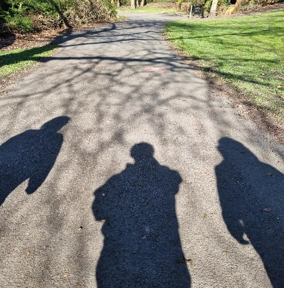
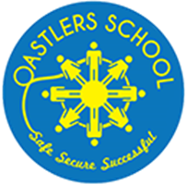
OASTLERS

TOGETHER
Parent/Carer Group
Newsletter September 2025 Issue #1
About Oastlers Together
Oastlers Together is a supportive community of parents and carers who gather regularly at school. The group fosters an environment that is welcoming and non-judgemental, allowing everyone to feel comfortable and valued.
Our Purpose
The main aim of Oastlers Together is to provide mutual support and empowerment. We recognise that, although each of our journeys with our young people is unique, there are many shared experiences among us.
Building Connections
Through sharing our individual journeys, we have discovered a sense of connection and understanding. This openness has helped us feel less isolated and alone, reminding us that we are not facing challenges by ourselves.
Looking Ahead
With this newsletter, we hope to keep everyone informed about our activities and future plans, ensuring that all parents and carers are included and supported as part of our group.
Testimonies
“I look forward to meeting up with the group. Everyone is very friendly, I feel safe and heard when sharing challenges I may be experiencing with my son. The ‘posh biscuits’ Lyndsey treats us too is always nice too.” - Sam, mum of a year 10 learner.
“What a fab group, I always look forward to the meet ups! I’ve even learned a few new skills, such as wreath making and crocheting. Such a warm welcoming group.” Nadine, parent/carer of learning in year 9.
Upcoming events
- Friday 12th September 10:00 – 12:00
We look forward to welcoming you along.

Gallery of things we get up to

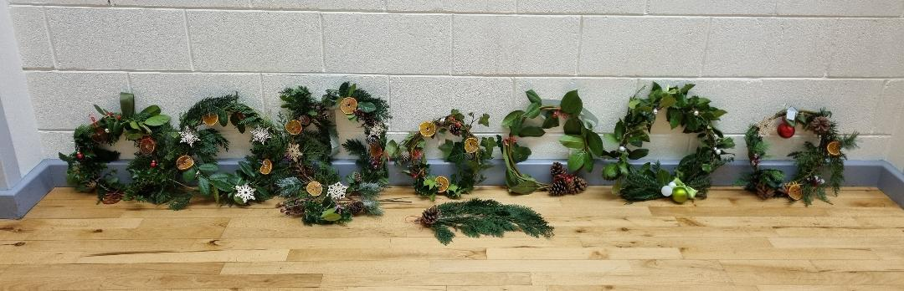

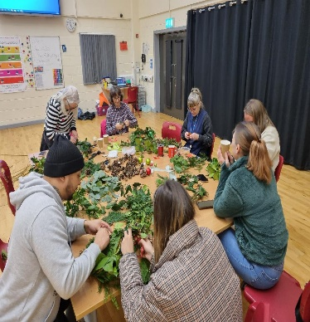
Christmas wreath making.
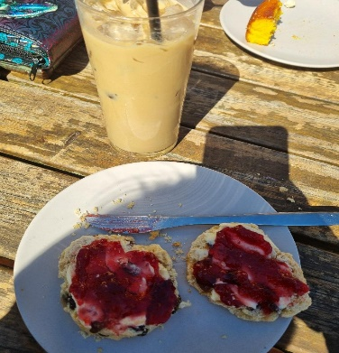

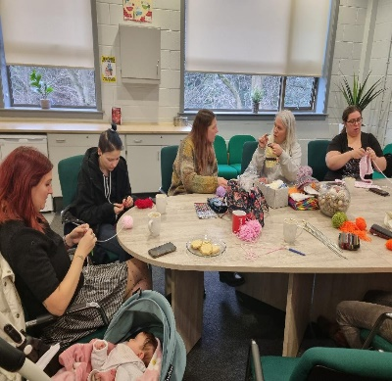
Café trip.

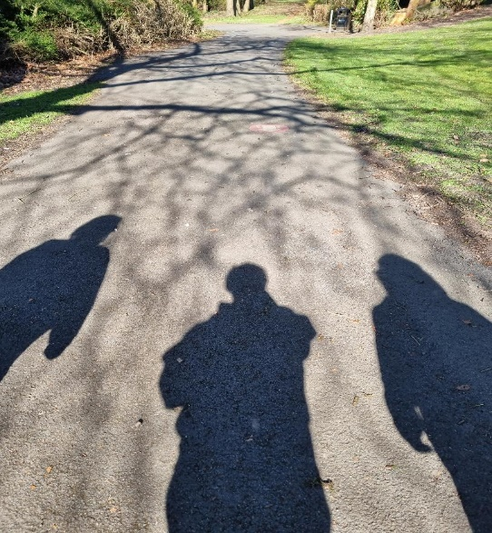
Knitting and crochet.
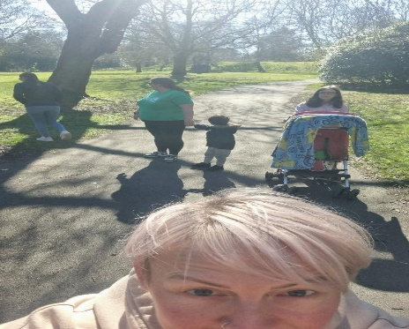

A walk in the park.

