School Uniform Policy

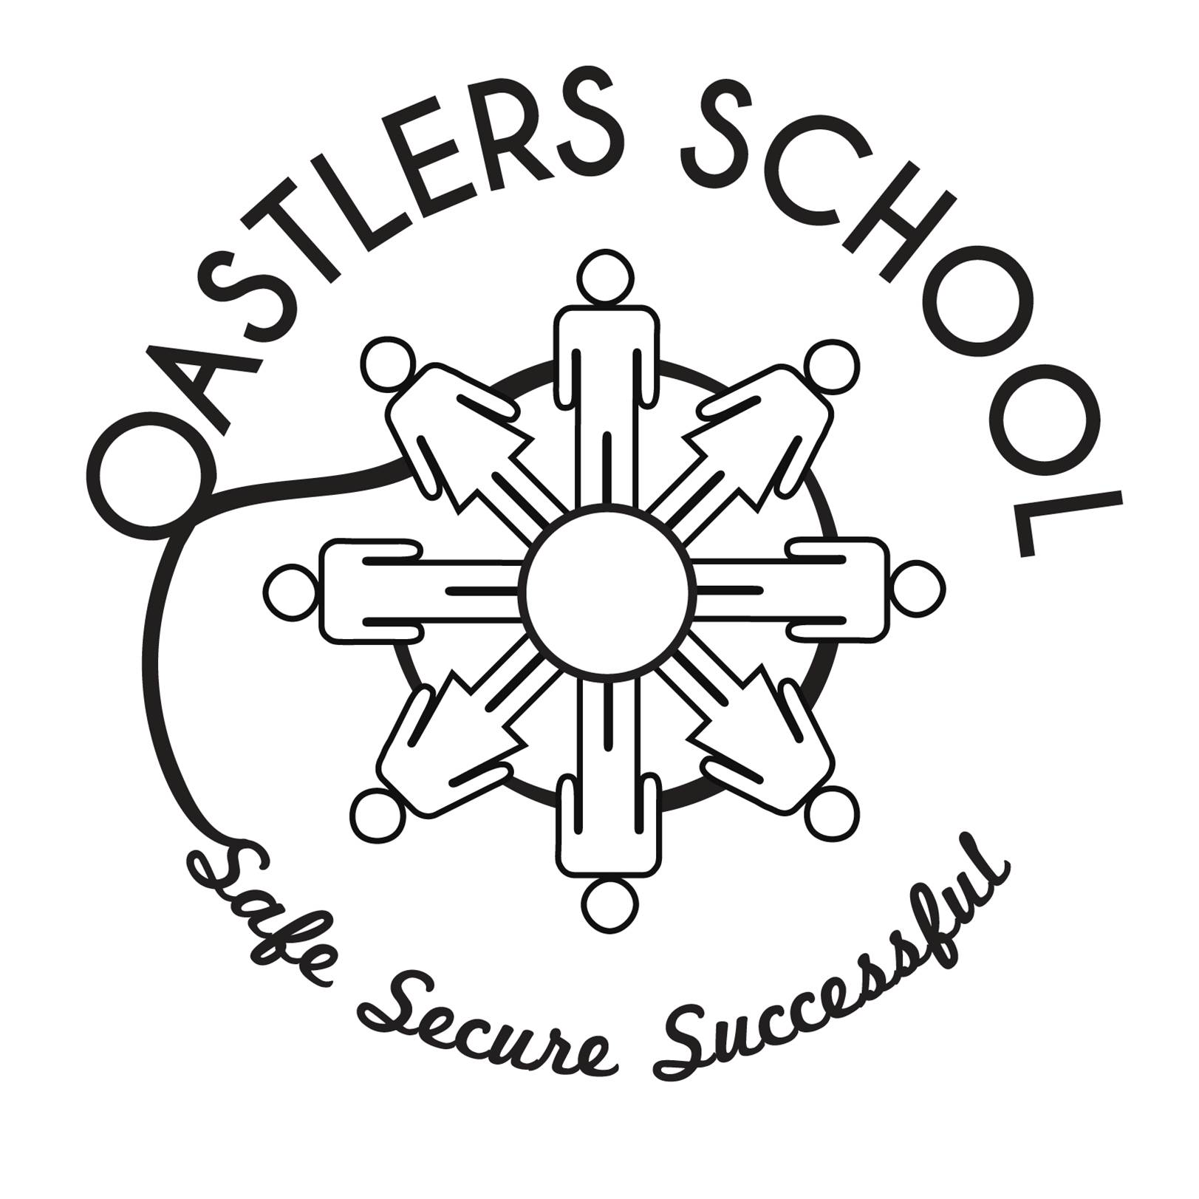
P

Oastlers Policy

Approved by Governing Body On | September 2026
To be Reviewed On | September 2028
Signed on Behalf of the Governing Body | David Ward

Updated 17 June 2013

School Uniform Policy

At Oastlers School we believe that a school uniform is an important part of school life. Following consultation with our learners, we believe our uniform is practical, comfortable and suitable for all. Our uniform is simple, easy to understand, gentle on the environment and inexpensive. During hot summer months, we adopt a flexible approach and make exceptions such as wearing black shorts instead of trousers for example.

Uniform and dress codes

Uniform | Gender | Comment
Blazer | Boys & Girls | Plain black blazer with school logo
V-neck sweatshirt | Boys & Girls | Plain black V-neck sweatshirt with school logo
White shirt | Boys & Girls | Plain white shirt with long or short sleeves
School tie | Boys & Girls | Blue and red striped tie
Trousers | Boys & Girls | Plain black school trousers (no joggers or jeans) or skirt (below knee)
Socks | Boys & Girls | Plain black or grey school socks
Black footwear | Boys & Girls | Plain black footwear (not crocs) any laces must also be black and no branding logos

Physical Education Kit
Shorts | Boys & Girls | Black shorts
Tracksuits | Boys & Girls | Black or blue tracksuits for outdoor sports optional
Polo shirt | Boys & Girls | White polo shirt
Socks | Boys & Girls | White sports socks
Training shoes / plimsolls | Boys & Girls

Swimming Kit
Swimsuit | Girls | Black or blue one-piece suit
Swimming trunks | Boys | Plain blue or black trunks or shorts

Protective Dress Wear and Safety Equipment

In consideration of the Health and Safety Act, protective dress wear and safety equipment must be worn and used by all learners and those using or operating dangerous equipment and/or materials. Class teachers and Inclusion Leaders are responsible for monitoring that learners wear the correct equipment and suitable clothing while using or operating dangerous equipment and/or materials ensuring that safety concerns are in line with school safety policies and guidelines.

Hair

While recognising that each learner will wish to wear her/his hair in an individual style, extreme hairstyles are unacceptable.

Hair should be of a natural colour and should be cut no shorter than a grade 2 with no patterns cut into the style. All long hair should be tied back.

No eyebrow patterns are allowed.

Make-up

No make-up or nail varnish should be worn, including wearing acrylic and gel nails and false eyelashes.

Jewellery

Jewellery is not to be worn – this includes earrings, nose piercings, lip piercings, eyebrow piercings, necklaces, rings and bangles. This applies to both male and female learners.

Watches are permitted with the exception of Smart Watches.

Identification of clothing

All clothing/footwear must be clearly marked with the learner’s name.

Lost property

Any items found in school will be stored in lost property. Please contact the school in the case of lost or missing items. Lost property and unclaimed items will be stored for a period of no more than twelve months. Following this, items will be deposited at a local clothing bank.

Mobile Phones and other electrical devices

Mobile telephones are not allowed in school. Phones must be handed in at the start of the day.

Enforcement of the Uniform Policy

It is the responsibility of a parent/carer to ensure that their child comes to school in the correct uniform.

Class teachers and Inclusion Leaders are responsible for monitoring school uniform; all staff have a responsibility for ensuring that ALL learners are correctly dressed in class and elsewhere on the school site.

The Headteacher who will, if necessary, refuse entry to a learner until such time as his/her uniform, hairstyle or appearance is deemed appropriate.

Cost of uniform

We want to ensure that the cost of uniform does not deter any learner from applying to the school, nor leads to them feeling socially excluded or unable to afford other necessities. Parent/carers who are unable to provide their child with the required items of Oastlers uniform should contact Rebbecca Fyfe on 01274 307456.

Sixth form

Learners in the Sixth Form are not required to wear the standard school uniform. However, they are expected to dress in smart business or office attire that is appropriate for a professional working environment.
Suitable clothing includes smart shirts, blouses, tailored trousers, skirts, dresses, and smart footwear. A shirt and tie are encouraged for those choosing traditionally formal business wear.
The following items are not permitted:
- Sportswear, including tracksuits
- T-shirts with logos or slogans
- Jeans or other denim clothing
- Hoodies, sweatshirts, or casual leisurewear
- Trainers that are not black
Learners should also avoid wearing excessive jewellery, as the school cannot accept responsibility for the loss or damage of valuable items.

